Scottish Rugby Club Tickets – 2024 Guinness Six Nations

MEMBERS APPLICATION
To be completed by individual club members and returned to ticket secretaries.

To apply for interna.onal match .ckets, you must have an online .cke.ng account with Sco:sh Rugby. Match .ckets will be delivered via the Sco:sh Rugby Ticke.ng Ap, therefore, if you do not have an account, please visit sco:shrugby.ckets.com and register now.
Please ensure the below details are completed in full before submission.

Club member’s details

First Name | ( | Surname
Scottish Rugby e-ticketing client reference
(This can be found by logging in to your account. The client reference can be found by clicking ‘My Account’.)
Email
Telephone | Landline: |  | Mobile:

Pricing & Fixtures
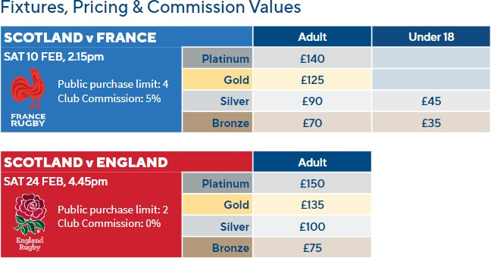

Club Order & Payment Process

As of season 2022/23 you will pay for your 4ckets through your online 4cke4ng account.

You will con4nue to order via your secretary and will receive an email once your 4ckets are ready for payment.

Once logged into the 4cke4ng site, you can select whether your 4ckets are Adult, Under 18. Full video guidance and FAQs are available at askscoGshrugby.org

Your Ticket Order

Scotland v France | Sat 10 Feb 2024, Kick Off 2:15pm | Platinum | Gold | Silver | Bronze
Quantity:

Scotland v England | Sat 24 Feb 2024, Kick Off 4:45pm | Platinum | Gold | Silver | Bronze
Quantity:
*No concession pricing available

Next Steps
Step 1: Please return this completed form to your Club Ticket Secretary by the deadlines communicated.
Step 2: Your Club Ticket Secretary will allocate your .cket using our club .cket alloca.on portal.
Step 3: You will receive an email no.ﬁca.on invi.ng you to make payment for your order. Once logged into your .cke.ng account you can add these .ckets to your basket and select whether your .ckets are Adult, under 18 (if categories are available). Please follow the instruc.ons and make payment for your .cket order.
Step 4: Delivery of .ckets can be as close to 2 weeks before the match. If for some reason you don’t receive your email with your match
.ckets, contact .cket.centre@sru.org.uk
Full instructions on how to complete payment for your transaction can be found here: https:// ask.scottishrugby.org/hc/en-gb/articles/360021579-Club-Tickets-Member-Instructions

Ticketing Terms & Conditions
The applica.on, alloca.on, purchase, use, sale or transfer of .ckets to Scotland’s home interna.onal rugby ﬁxtures is subject to Sco:sh Rugby’s Ticke.ng Terms & Condi.ons which are available at hTps://www.sco:shrugby.org/.ckets-and-events/.ckets-terms-and-condi.ons
By applying for, using or purchasing .ckets through the Sco:sh Rugby Club Ticket applica.on process you hereby conﬁrm that you have read and understood Sco:sh Rugby’s Ticke.ng Terms & Condi.ons and agree to be bound by them.
Without limi.ng any other remedies available, if you have breached (or in breach of) the Sco:sh Rugby Ticke.ng Terms & Condi.ons, Sco:sh Rugby shall be en.tled to refuse entry, cancel, conﬁscate or de-ac.vate the .cket and exclude you from purchasing future .ckets.

Personal Information
By applying for, purchasing and/or using a .cket, you conﬁrm that any personal informa.on you provide is accurate and up to date and you agree that Sco:sh Rugby Union Limited will collect and process your personal informa.on in accordance with its Privacy Policy which is available at www.sco:shrugby.org/privacy-policy

Declaration
I conﬁrm that I have read and accept Sco:sh Rugby’s Ticke.ng Terms & Condi.ons and that the informa.on I have provided is accurate and up to date.

Full Name
Signature |  | Date

