
Hospitality Booking form 2023

Please complete details to confirm your order and return no later than
Tuesday prior to Matchday
Please return to.
Email to Stirlingwolvesgm@stirlingcounty-rfc.co.uk

Hospitality package includes Gate entry 2 hours prior to KO, 2 course meal of the day,
half time mini pies and post-match cheese course.
All prices are inclusive of VAT.

Booking Name:
Point of Contact:
Email Address:
Tel No:
Attendance Numbers

 | Numbers | Price | Total Cost
Members |  | £50 | £
Non Members |  | £60 | £
Sponsorship Package |  | £0.00 | £0.00
Pre order Drinks | Please see below pricing | £ | £
Total |  |  | £

Pre order drinks
Start as you mean to go on, order some chilled bubbles and wine for the table from the moment you arrive.

Drinks | Price | Quantity | Total Price
Champagne & Sparkling Wine
Prosecco | £28
Brute | £24
White Wine
Esk Valley Sauvignon Blanc New Zealand | £31
False Bay Sauvignon Blanc South Africa | £23
Ancora Pinot Grigio Italy | £21.50
Rose Wine
Ancora Monferrato Chiaretto Italy | £20
Red Wine
Holden Manz Vernissage South Africa | £32
Sensale Nero D’Avola Italy | £23
Ancora Montepulciano d’Abruzzo | £21.50
Water
Still | £4.00
Sparkling | £4.00
Beer
10 Bottles of Beer | £38.00
10 Assorted Beer and Cider | £41.50
Pre order Total

Signature: ________________________ Date: ______________________

For office use only Table Number:____________


SPARKLING 125 BTL
Palazzi Durello Brut 6.50 24.00
ITALY
A great alternative to Prosecco using a unique grape variety but made with the same method. Lovely crisp, delicate, appley fizz.
Cavit Prosecco 9.00 28.00
ITALY
A deliciously light and fruity Prosecco with hints of apple and peach on the nose and a fresh, softly sparkling palate with characters of soft ripe stone fruits.
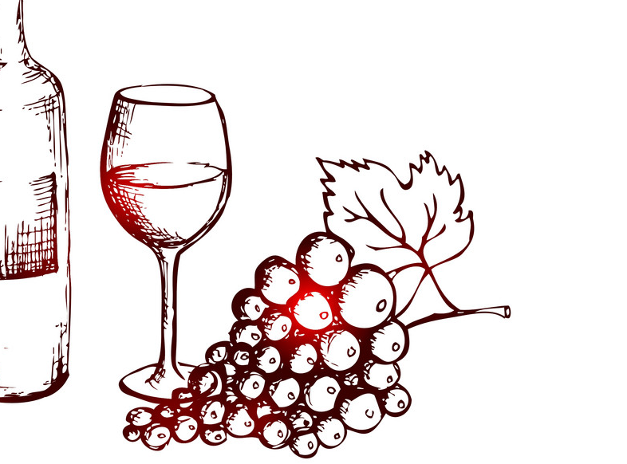
WHITE 175 250 BTL
Ancora Pinot Grigio 4.80 7.30 21.50
ITALY
Apple and citrus aromas lead to a crisp, clean, and delicate palate, with lightly floral note balanced by lemony acidity and a fresh, dry finish.
False Bay Sauvignon Blanc 5.50 7.50 22.00
SOUTH AFRICA
Sustainably farmed Sauvignon from a family-owned winery in South Africa. Wild yeast gives more complexity!
Esk Valley Sauvignon Blanc 30.00
NEW ZEALAND
Using grapes selected from the best vineyards, this fruity, full-on wine is full of passion fruit, stone fruits and citrus with a touch of herbaceousness and a lovely long finish.
ROSÉ 175 250 BTL
Ancora Monferrato Chiaretto 4.50 6.50 20.00
ITALY
Move aside Pinot Grigio rosé. This is a delicious blush rose from the North of Italy with soft strawberry fruit and a dry crisp palate.
RED 175 250 BTL
Ancora Montepulciano d’Abruzzo 4.80 7.30 21.50
ARGENTINA
Aromas of plum, juicy fresh cherries and subtle spices. The bright palate displays ripe red fruit and blackberry flavours offset by fresh acidity, robust, youthful tannins and hints of bitter chocolate.
Sensale Nero D’Avola 5.50 7.50 22.00
ITALY
Charming raspberry coulis character and organic to boot! Red fruit notes such as black cherry and plum. Fresh and balanced.
Holden Manz Vernissage 31.00
SOUTH AFRICA
A decadently rich red blend with layers of prunes, mulberries and ripe cherries, surrounded by cloves and smoky tones.

